HW 1- Part 2- Problem 1
This model uses policy gradient with a non-constant baseline (V(t)).
The model was stopped when the average of the last 100 episodes reached 195. The model could have been trained further to reach to reach an average of the last 100 rewards up to 199 ( it occurred several times during previous runs). However, in this case we stop at 195.
The result of the episode rewards is shown below:
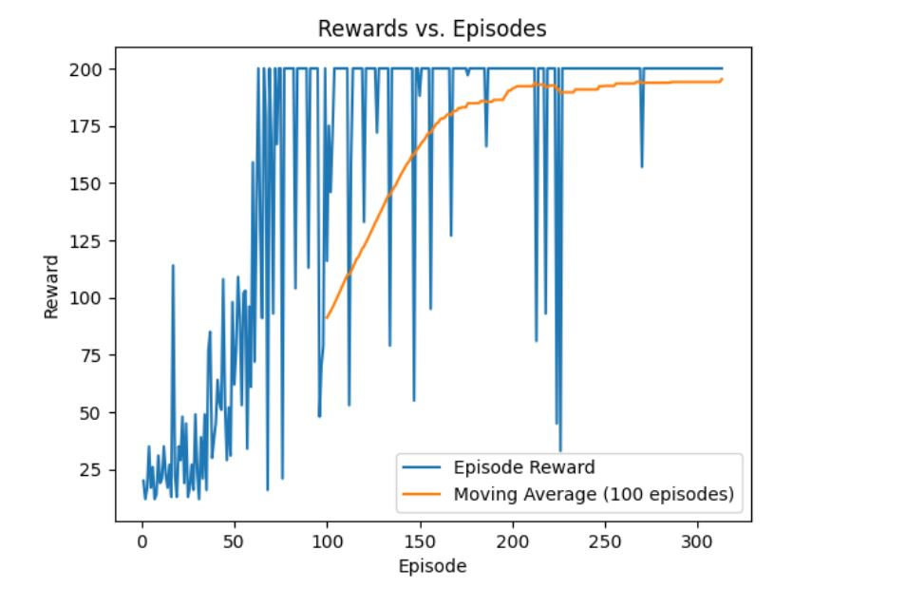
When compared to the algorithm REINFORCE without a baseline (or with constant baseline), we notice that this model converges way faster and has much less noise than the model without a baseline. The performance of this model is exquisite. It learns almost exponentially.

After training the model, we sample 500 episodes, and run the game using the trained policy; we get the following histograms. Both histograms apply to the same sample of episode rewards, but with different number of bins.
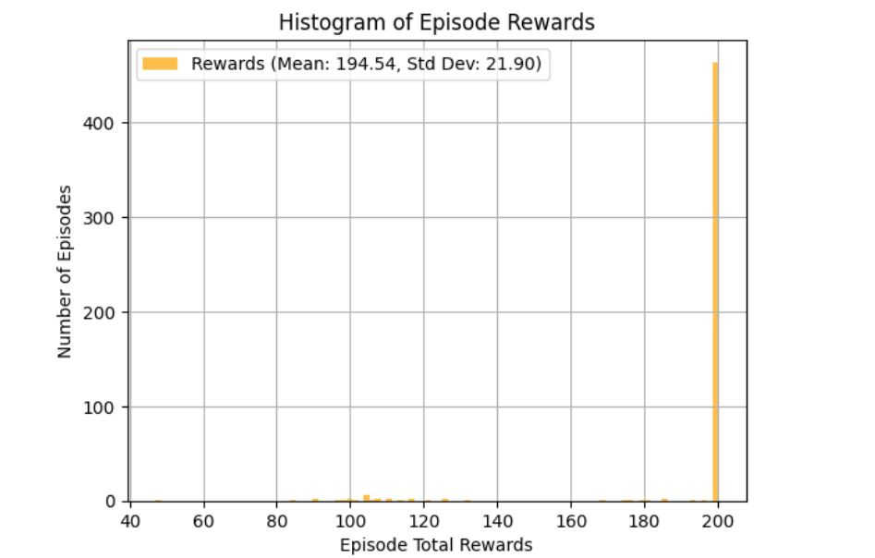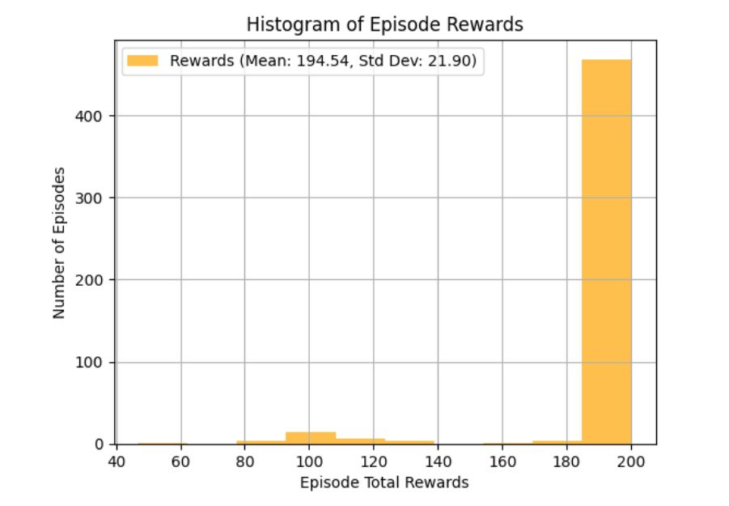

These results are promising. The mean can be higher, if we train the model a little further beyond an average reward of 195.

